14. Handling database exceptions and error condition.

use school;
CREATE TABLE employees6(
id INT PRIMARY KEY,
name VARCHAR(100)
);
CREATE TABLE errorlogs1(
id INT AUTO_INCREMENT PRIMARY KEY,
error_message VARCHAR(255),
error_time DATETIME
);
DESCRIBE employees6;
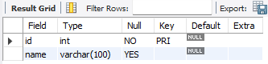
DELIMITER $$

CREATE PROCEDURE InsertEmployeeSafe(
IN emp_id INT,
IN emp_name VARCHAR(100)
)
BEGIN
DECLARE CONTINUE HANDLER FOR SQLEXCEPTION
BEGIN
INSERT INTO error_logs(error_message, error_time)
VALUES ('Error occurred while inserting employee', NOW());
END;

INSERT INTO employees(id, name)
VALUES (emp_id, emp_name);
END$$
DELIMITER ;
DROP PROCEDURE IF EXISTS InsertEmployeeSafe;
CALL InsertEmployeeSafe1(1, 'Gauri');
SELECT*FROM errorlogs2;

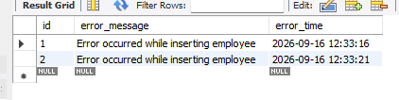
CALL InsertEmployeeSafe1(1,'Duplicate Gauri');
SELECT*FROM errorlogs2;

